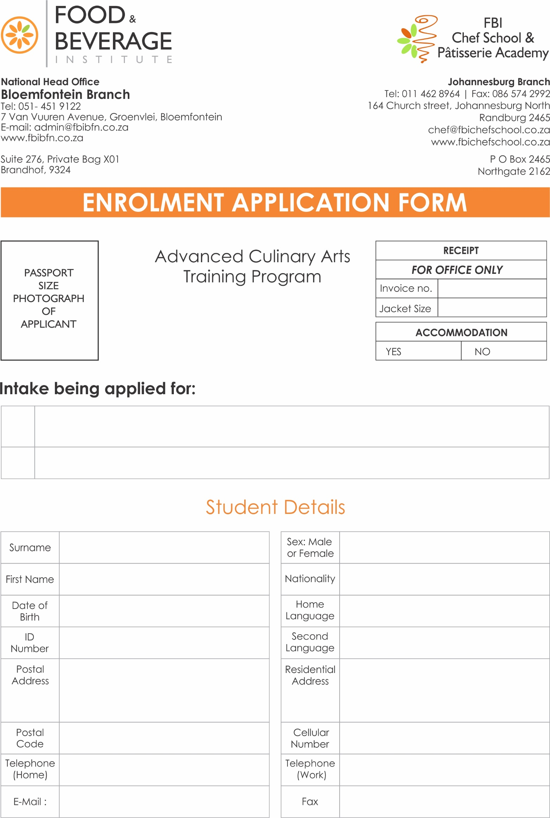

QCTO Occupational Certificate: Cook (512101) - NQF Level 4

QCTO. Occupational Certificate: Chef (101697) - NQF Level 5

Including City and Guilds Diploma in Food Preparation & Diploma in Patisserie

